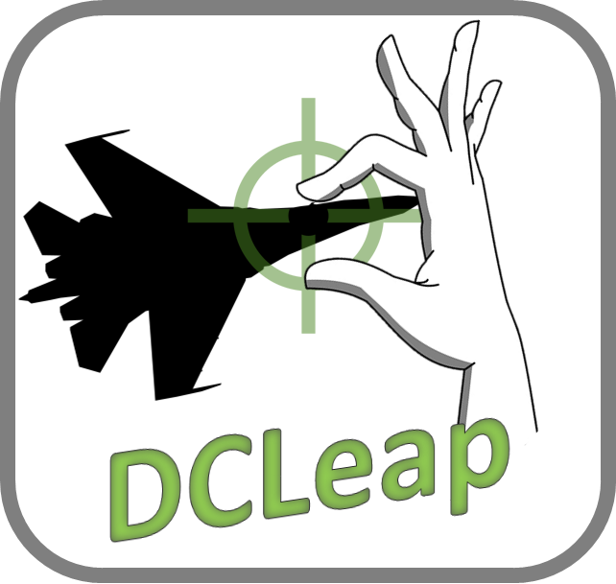

v 1.20

June 2nd 2020

# Overview

DCLeap is a Windows application, running in background, to control the movements and events of the mouse and the achievement of specific actions related to the gestures of the hands, all in a virtual reality environment.

**DCLeap is compatible with Oculus, you’ve to force SteamVR with** the *--force_steam_vr* command line

## DCLeap software and hardware

DCLeap is composed of :

* Mouse movement management module ;
* Module for managing events linked to the mouse (right and left clicks);
* Module for detecting interactions in the context of hand gestures.

DCLeap was developed in C # with Unity and uses the following solutions :

* Win32 C# mouse ;
* InputSimulatorPlus by TChatzigiannakis ;
* LeapMotion Core SDK for Unity ;
* LeapMotion Interaction engine for Unity ;
* OVRLay by BenOtter.

The prerequisites of DCLeap are:

* Virtual reality HMD ;
* Headmounted LeapMotion device ;
* DCS World ;
* SteamVR, beta or stable ;
* Drivers CBuchner *driverleap (*<https://github.com/cbuchner1/driver_leap>*)*;
* Drivers SDraw *driverleap* (<https://github.com/SDraw/driver_leap>)

## Installation

**Starting from the premise that DCS World, SteamVR and the two "driverleap" are already installed,** unzip the DCLeap.7z archive to the location of your choice. Then, open DCLeap.exe.

Set your settings as desired.

Once filled in, click “Save Settings” button, these settings are stored in Windows registry.

**This registration in the registry is the only entry generated outside the folder in which you unpacked DCLeap.**

These registry keys are under:\Computer\HKEY_CURRENT_USER\Software\Leap4DCS\DCLeap

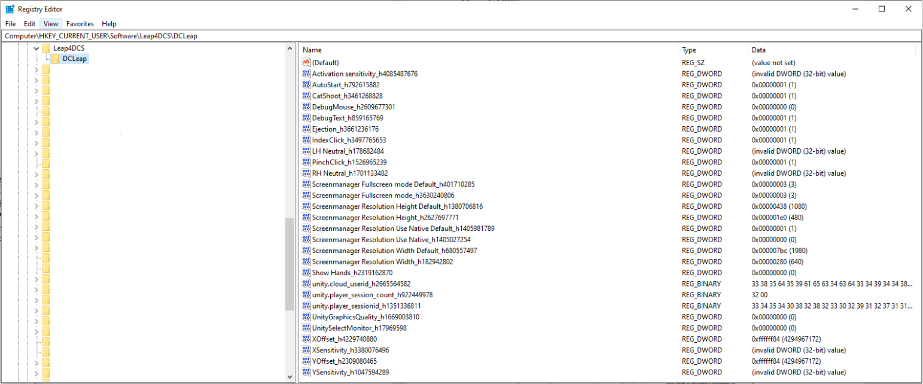

Check the creation of these keys by launching Regedit via the Windows command prompt (Win + R key).

If the keys have been correctly generated and the associated values ​​are correct, run the DCLeap.exe executable.

You should see the Unity window below, make sure the windowed mode is enabled, and then click "Play! ".

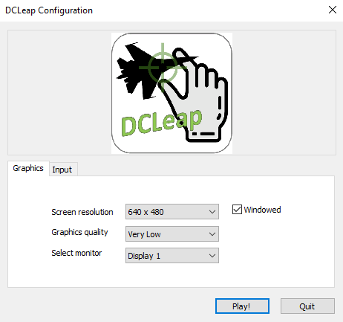

Before launching DCLeap, if you’re new to LeapMotion and SteamVR, ensure that :

* Leapservice is running
  + in windows type “services.msc” then scroll down to find *Leap Services.* In not running left click on *Leap Service* line then Start



* + Your Leap Monitor should show this :



* In the Leap Monitor settings panel that *Allow Images* is checked and in the Tracking settings *Robust Mode* and *Auto-orient Tracking* are both checked too
* SteamVR is running and your LeapMotion is recognized as Steam’s controllers

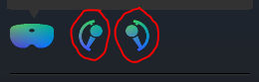

* It is advised to control and edit your control_config.xml file located under your SteamVR Leap Motion driver \leap\cfg folder as below. Be sure that *orientation value* is “hmd”. In the second block of text, you can disable inputs to avoid parasite control with DCS.

Mind that this will disable interaction inputs of virtual Steam Vive/Index controller emulated by the LeapMotion driver. So if you use LeapMotion with others SteamVR games mind to enable these inputs.

#### <config>

#### <param name="emulated_controller" value="index"/> <!--"vive" or "index"-->

#### <param name="rightHand" value="true"/>

#### <param name="leftHand" value="true"/>

#### <param name="orientation" value="hmd"/> <!--"hmd" or "desktop"-->

#### <param name="desktopRoot" value="0.0 -0.5 -0.5"/> <!--Only in desktop orientation-->

#### <param name="rotationOffset" value="0.0 0.0 0.0"/> <!--Euler angle in radians-->

#### <param name="skeleton" value="true"/> <!--Only Index controller-->

#### <param name="trackingLevel" value="partial"/> <!--"partial" or "full", only Index controller-->

#### 

#### <param name="input" value="false"/>

#### <param name="menu" value="false"/>

#### <param name="appMenu" value="false"/> <!--Only Vive controller-->

#### <param name="trigger" value="false"/>

#### <param name="grip" value="false"/>

#### <param name="touchpad" value="false"/>

#### <param name="touchpadTouch" value="false"/>

#### <param name="touchpadPress" value="false"/>

#### <param name="touchpadAxes" value="false"/>

#### <param name="buttonA" value="false"/> <!--Only Index controller-->

#### <param name="buttonB" value="false"/> <!--Only Index controller-->

#### <param name="thumbstick" value = "false"/> <!--Only Index controller-->

#### </config>

# Usage

## Main Menu

When DCleap is launched, you will access this window, Main Menu, where you can ;

* Define mouse sensitivity ;
* The cursor offset, if you prefer to have the cursor upper, lower more to the left or more to the right;
* Allow hand signals;
* Allow texts popup ;
* Define click method by allowing pinch and/or index trigger gesture;

*Sometimes, trigger gesture is not identified due to relative position of your hands and the LeapMotion device, that’s why* ***I advise you to check both Pinch and Index to execute clicks****. Indeed, when Trigger is not recognized, I realize the click with a Pinch.*

* Define the sensitivity of the pinch gesture;

*In other word the distance between your thumb and index, the less it is, more sensitive is the pinch.*

*When Pinch is activated, the cursor is not moving, so if sometimes you try to click on something and your cursor is not moving, this is probably because the pinch is activated. if it happens too often to your liking, maybe try to increase this value*

* Knob neutral position ;

*To perform a knob rotation, you must execute a pinch gesture, maintain this gesture and then roll to the right or to the left and maintain the position. the more you hold this position in time, the higher the rate will be.*

*This cursor will define the neutral position of your wrist, position in which no knob rotation command is sent.*

* Enable the gesture recognitions features.

*To execute hand signal, you must activate the virtual hand by facing palm.*

*For Catapult Shoot and Automatic StartUp, face your right palm, get the green square and then execute the gesture.*

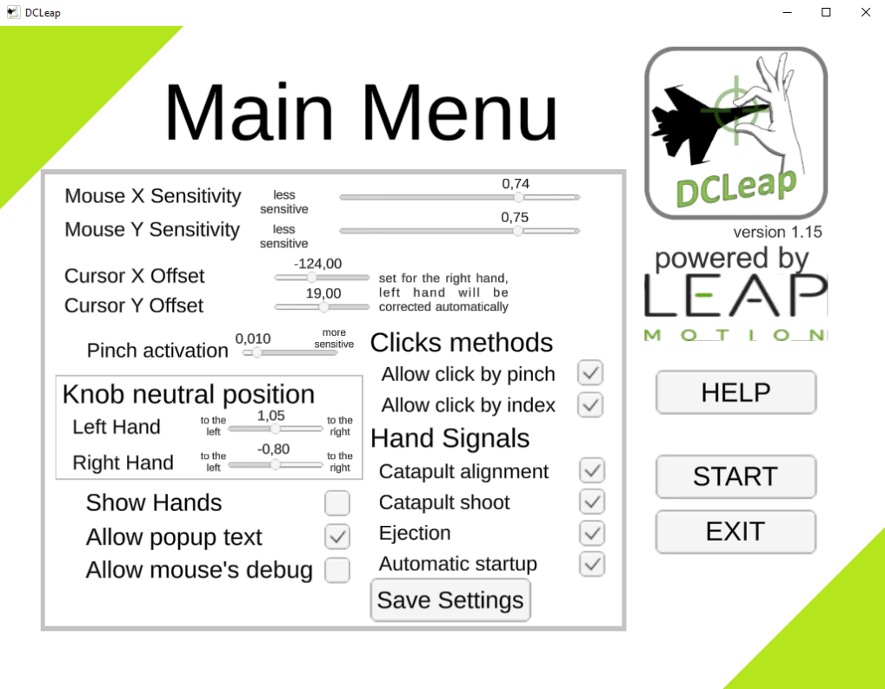

## Help Menu

From this window you can access help reminding the different gestures implanted.

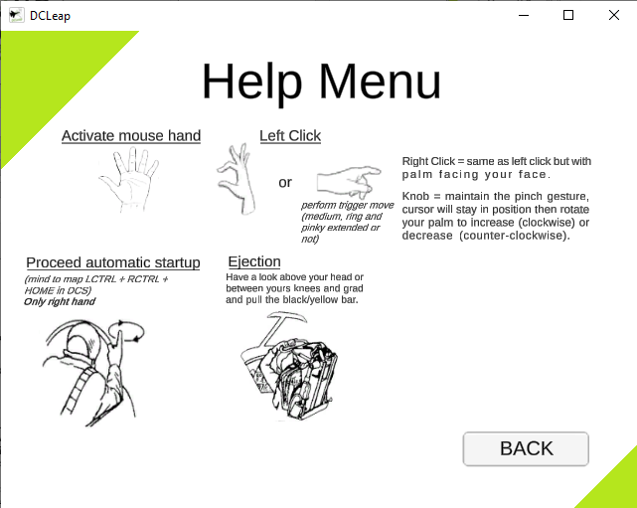

## Start Button

Once you have pressed the Start button, you should see two red and green squares appearing in your VR headset, indicating the activation of the virtual mouse.

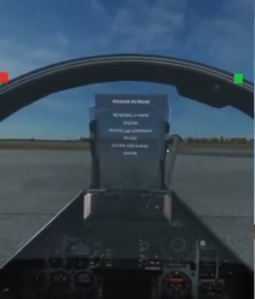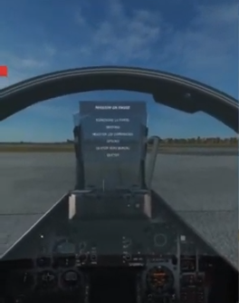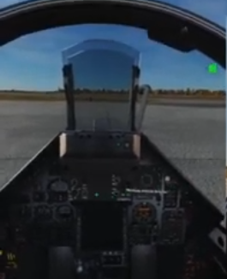

Figure 1 – From left to right - both hands move the mouse, only the left hand, only the right

The red square indicates that the mouse control is slave to the left hand, the green square indicates that the control is slaved to the right hand. In order to avoid any disruption related to activation of both hands tracking, it is best to assign mouse tracking to one hand at a time.

DCLeap will tell you when right click is available as shown under (blue square around green/red square).

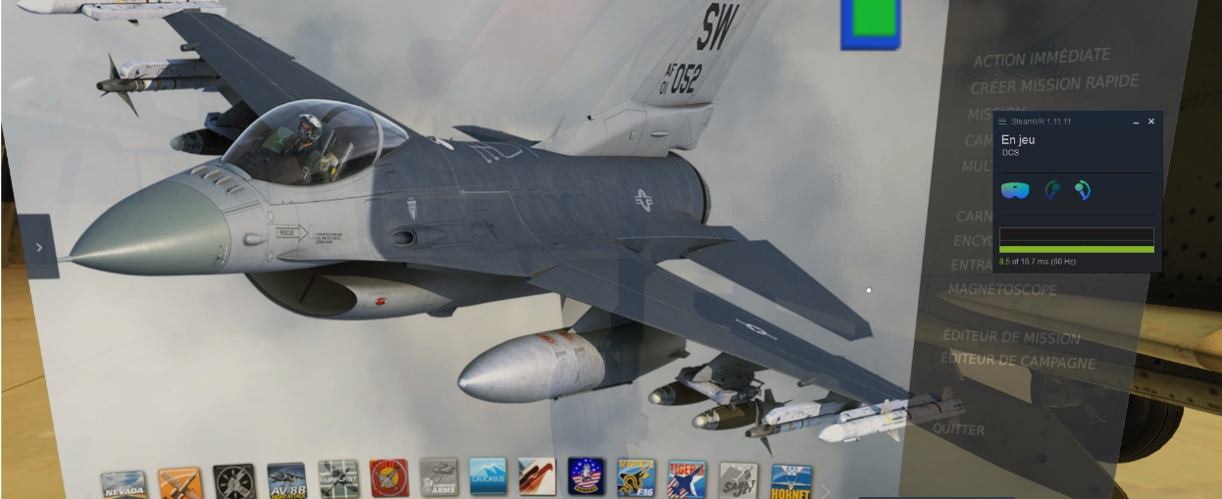

### Trigger clicks

To execute a trigger click, you need to extend your thumb and your index and after execute trigger gesture. Middle, pinkie and ring can be extended or retracted, it doesn’t matter.

### Pinch

Pinch is used to execute standard click and knob rotation. To execute pinch gesture, all fingers can be extended. When you activate pinch, mouse cursor stay in fixed position, then you can rotate your wrist (maintain pinch gesture) as you will be rotating a knob. Sensitivity in accordance with Main Menu set.

### Catapult shoot

DCLeap allow you to execute catapult shoot with the salute gesture. Currently this action is mapped to LSHIFT + LCTRL + S, keybind used by Supercarrier module. **You’ve to change key mapping in DCS command menu.**

When you execute “Salute” you will see “Catapult Shoot !” in red letters on top right of your HMD (if Allow debug text is ticked in the Main Menu).

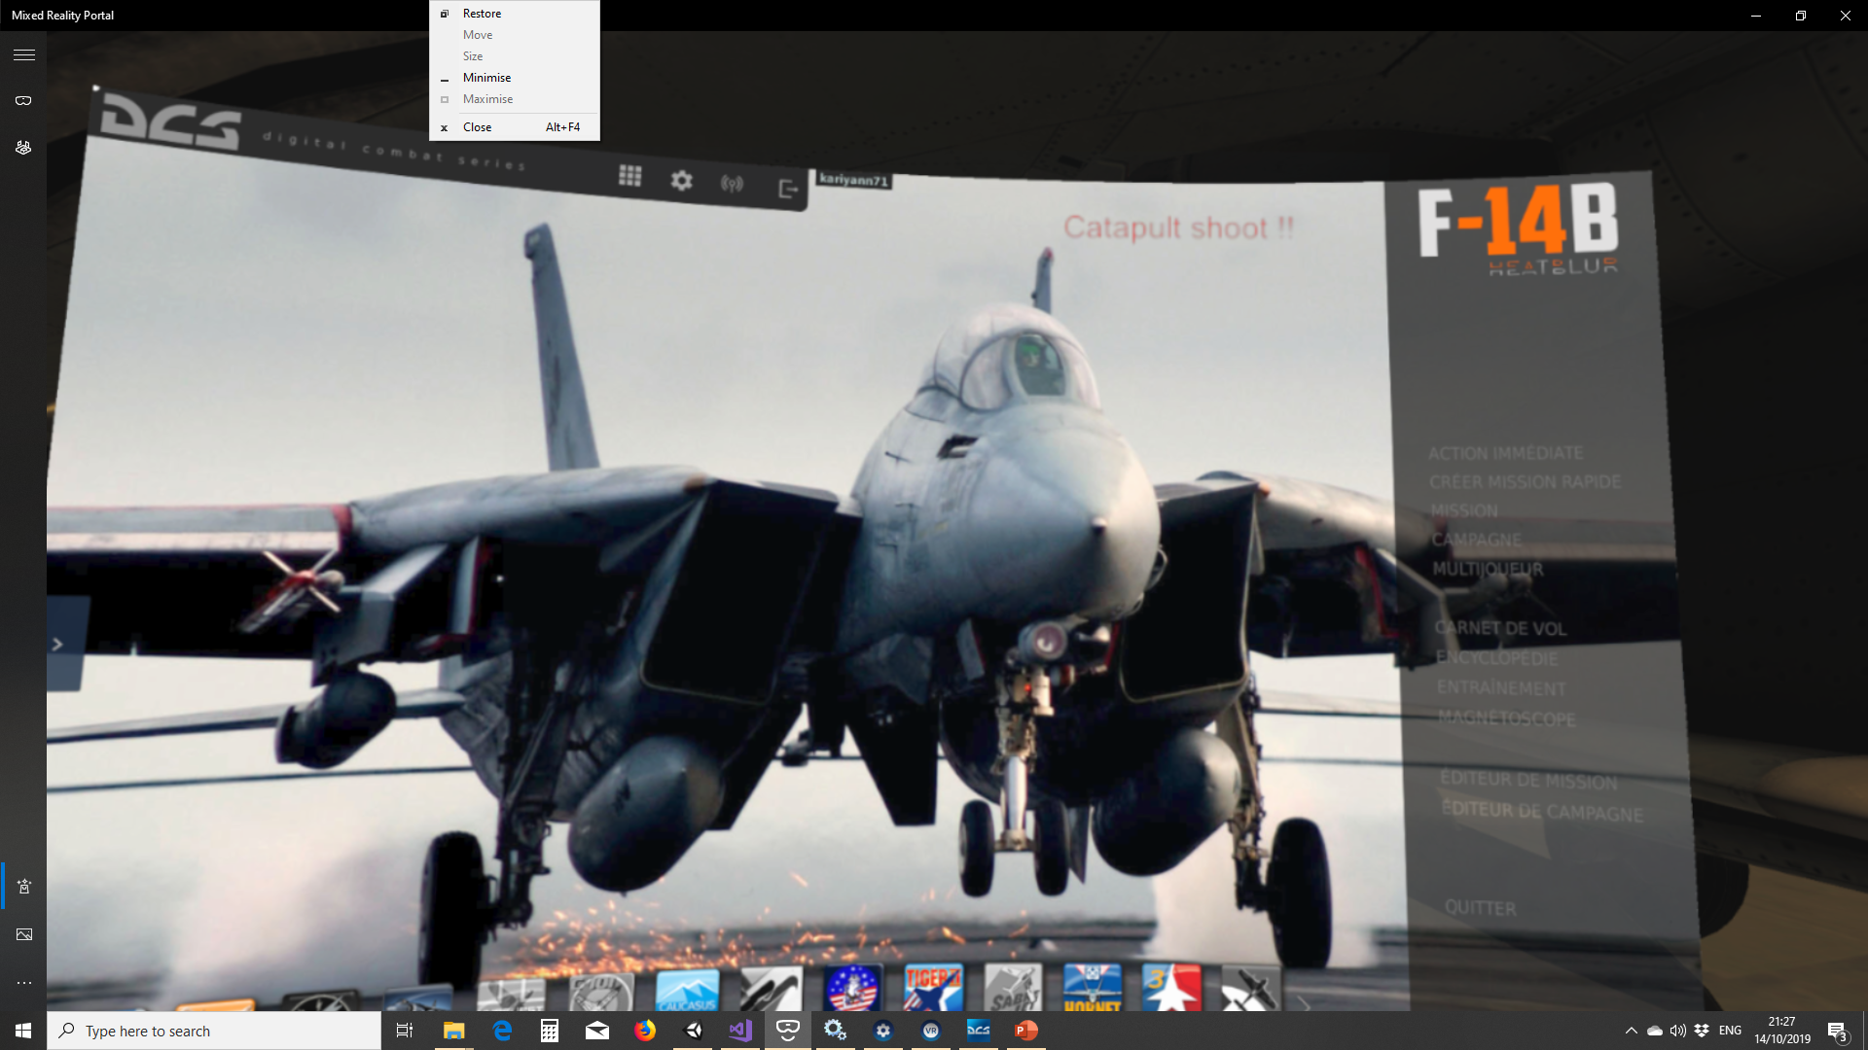

### ~~Catapult alignment (deprecated)~~

~~You can align your aircraft to catapult (Keyboard U) with Thumb up gesture. As for catapult shoot, you will see “Catapult Align” in red letters (if Allow debug text is ticked in the Main Menu).~~

### Start-Up

You can execute an automatic start-up procedure by pointing right index finger vertically and gently circling your hand (index must point to the sky for 2 seconds). Mind to map LCTRL + RCTRL + HOME in DCS commands menu.

### ~~Recenter VR view (deprecated)~~

~~You can execute a VR recenter view by closing both fists, palms directions don’t matter.~~

~~Mind to map LSHIFT + RSHIFT + HOME (this can be done by performing fists closed gesture).~~

### Ejection

You can call ejection command by grabbing the handlebar over your head. When your hands will be close the handle, they will be shown in order to help you to grab the handle.

When grabbed, DCLeap will execute ejection’s command.

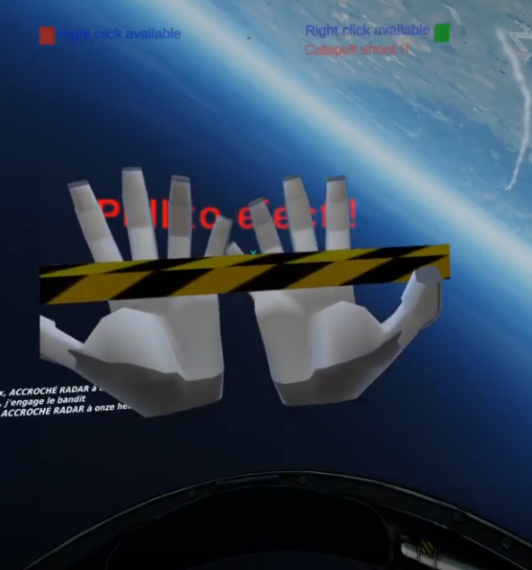

### Kneeboard

You’ve to activate your left hand, then press on your left thigh.

This will activate both hands and DCLeap kneeboard’s overlay.

When over a button, background will turn to blue, when clicked, it turns to green.

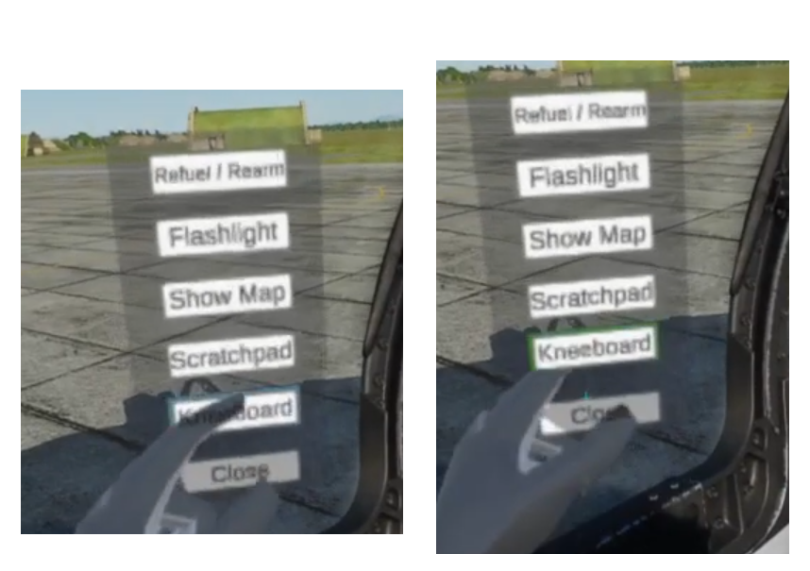

## Quit

To exit the application, press the LCTRL + Escape keys. Then click on the "Quit" button in the main menu.

Other, DCLeap automatically quit when SteamVR is shutdown.

## Debug file

A debug file is generated each time you load DCLeap. Old log is erased before writing a new one.

This file is called Logfile.txt and is contained in the DCLeap_Data folder.

In case of issue, please attach this file in your post in the DCS forum, or others.

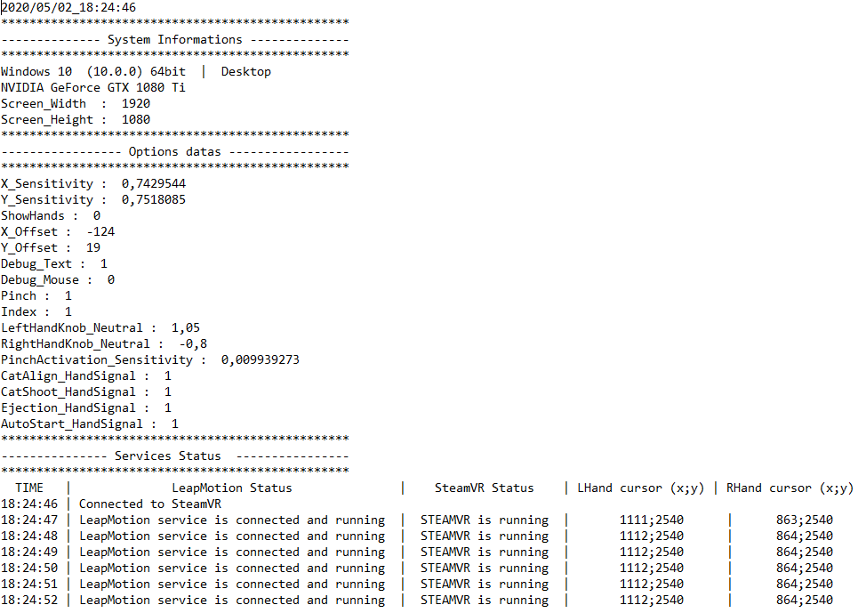

***Example of generated LogFile***

# To go further, or to better understand

## Pinch gesture

Here is the illustration under Unity of the pinch gesture zone (the red one) and the release pinch zone (the blue one).

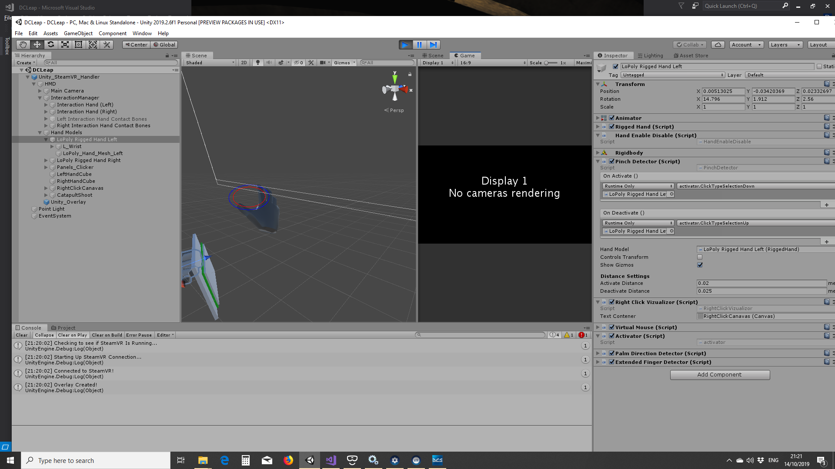

## Palm facing zone

When the white line (line between the HMD and the palm) enter in the red cone, LeapMotion detect your hand is facing your head. Currently the red cone is set at 45°.

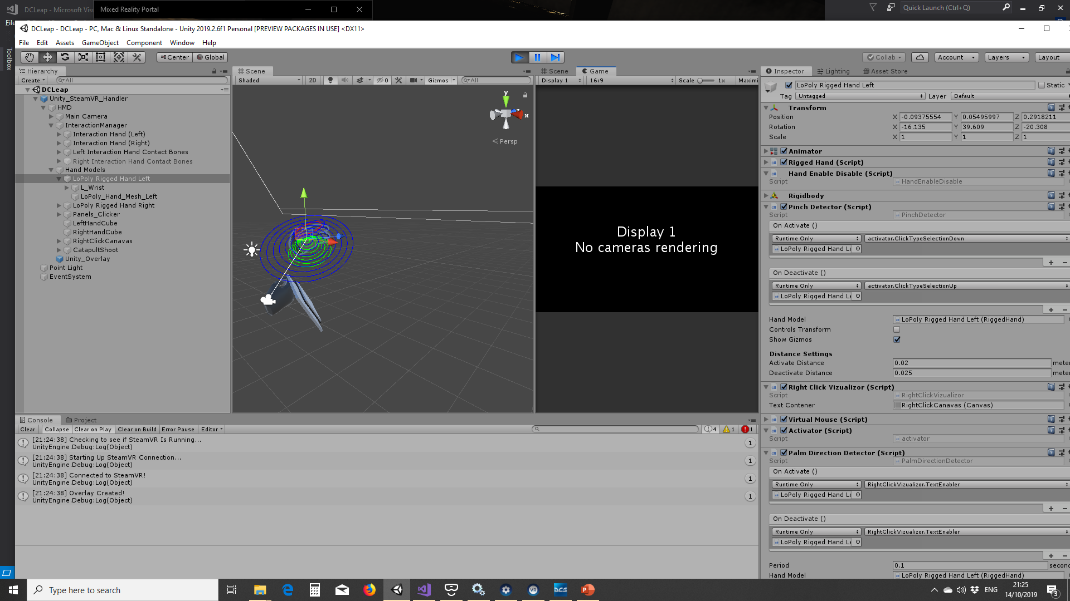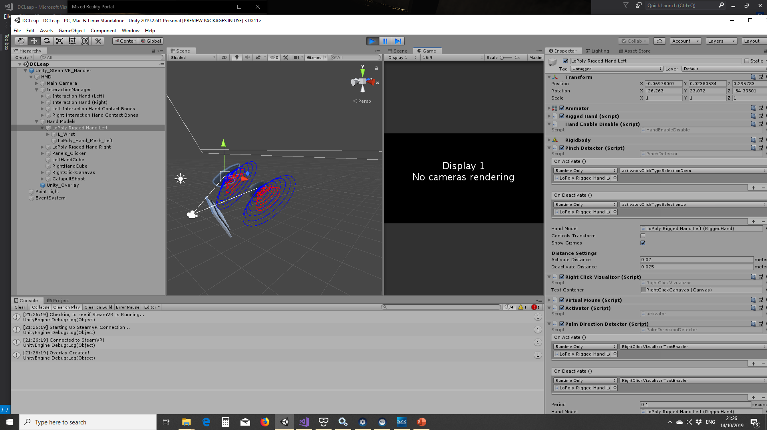

## Keybindings

|  |  |
| --- | --- |
| **Function** | **Keystrokes (to map in DCS)** |
| Salute | LSHIFT + LCTRL + S |
| Flash Light | LALT + F |
| Next Page (kneeboard) | Page Up |
| Previous Page (kneeboard) | Page Down |
| Start Up | LCTRL + RCTRL + Home |